**Lab Assignment - 1**

**Name:** Khushi Prasad

**Subgroup:** 2CO20

**Roll No. :** 102183044

Q1. Discuss the concept of Networking, advantages, disadvantages and applications.

Ans. Computer networking refers to interconnected computing devices that can exchange data and share resources with each other. These networked devices use a system of rules, called communications protocols, to transmit information over physical or wireless technologies. Network devices include things such as routers, switches, hubs, and bridges.

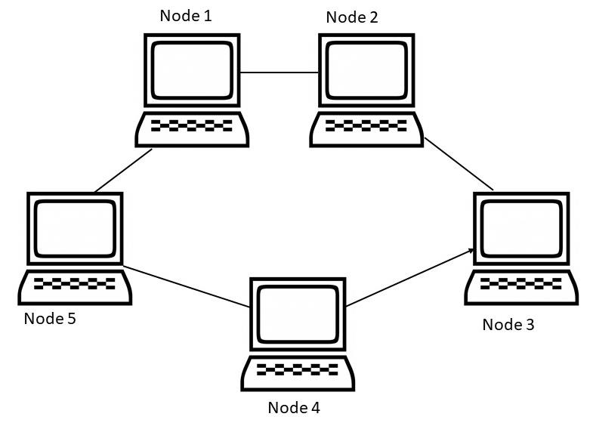

Advantages of Networking –

1. Enhances communication and availability of information.
2. Allows for more convenient resource sharing.
3. Makes file sharing easier.
4. Inexpensive System.
5. Increases cost efficiency.
6. Boosts storage capacity.

Disadvantages of Networking –

1. It lacks independence.
2. Poses security difficulties.
3. Lacks robustness.
4. Requires an efficient handler.
5. Requires an expensive set-up.
6. Allows more presence of computer viruses and malware.

Applications –

1. Marketing and Sales
2. Manufacturing
3. Financial Services
4. Teleconferencing
5. Server-Client Model
6. eCommerce

Q2. Discuss the peer-to-peer connections and multipoint connection.

Ans. In peer-to-peer (P2P) networking, a group of computers are linked together with equal permissions and responsibilities for processing data.

The multipoint connection is a connection established between more than two devices.

Q3. Discuss the components required to make a computer network.

Ans. Computer networks components comprise both physical parts as well as the software required for installing computer networks, both at organizations and at home. The hardware components are the server, client, peer, transmission medium, and connecting devices such as routers, bridges, hubs,. The software components are operating system and protocols.

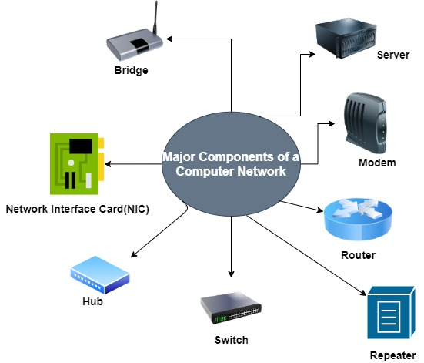

Q4. Discuss the types of networks as LAN, WAN and MAN.

Ans. The Network allows computers to connect and communicate with different computers via any medium. LAN, MAN, and WAN are the three major types of networks designed to operate over the area they cover.

LAN –

1. Local area network is a group of computers connected with each other in a small places such as school, hospital, apartment etc.
2. LAN is secure because there is no outside connection with the local area network thus the data which is shared is safe on the local area network and can’t be accessed outside.
3. LAN due to their small size are considerably faster, their speed can range anywhere from 100 to 100Mbps.
4. LANs are not limited to wire connection, there is a new evolution to the LANs that allows local area network to work on a wireless connection.

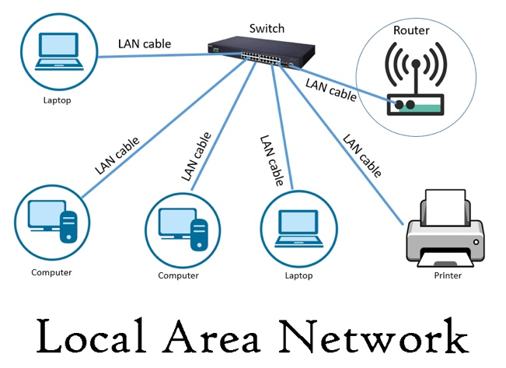

MAN –

1. In Metropolitan area network various Local area networks are connected with each other through telephone lines.
2. The size of the Metropolitan area network is larger than LANs and smaller than WANs(wide area networks).
3. A MAN covers the larger area of a city or town.

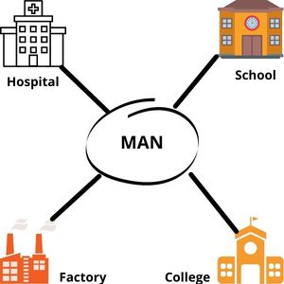

WAN –

1. Wide area network provides long distance transmission of data.
2. The size of the WAN is larger than LAN and MAN.
3. A WAN can cover country, continent or even a whole world.
4. Internet connection is an example of WAN. Other examples of WAN are mobile broadband connections such as 3G, 4G etc.
5. 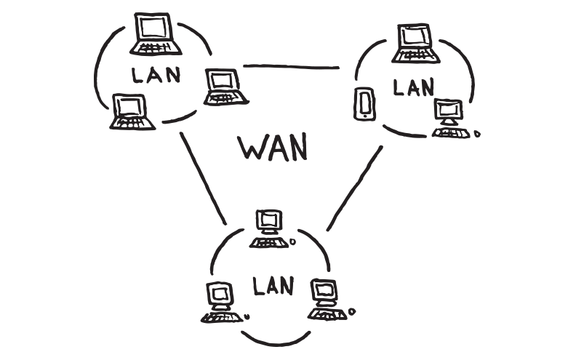

Q5. Differentiate between physical and logical topologies.

Ans. Physical topology can be considered as a layout of the network media that shows the interconnections of the devices on the network. It specifies which geometric shape the linked devices form with each other. The physical topology does not give much comprehensive detail about the type of devices, the mechanism used for interacting with other devices in the network, and how data is transferred from one device to another.

Therefore, it gives essential details of the network and network devices broadly, neglecting the higher level details like device type, addressing schemes, connectivity, and so on.

The factors that affect communication of devices on a network based on the physical topology selected are:

* Cost
* Scalability
* Bandwidth capacity
* Ease of installation
* Ease of troubleshooting

Eg. Bus, Star, Ring and Mesh

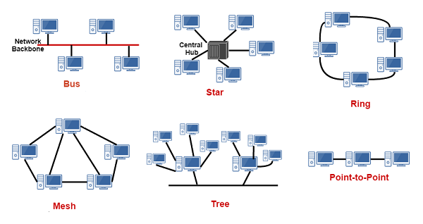

Logical Topology –

The logical topology emphasis on the manner in which data is transmitted between network nodes instead of the physical layout of the path that data follows.

As a logical topology is a signal path that passes through a physical topology. It handles the –

* Line discipline
* Ordered delivery of frames
* Error notifications
* Optimal flow control.

Eg. Logical Bus and Logical Ring

Q6. List the different types of networks from surroundings as client-server network, distributed networks, peer-to-peer networks and cloud based networks.

Ans. Examples of computer applications that use the client-server model are email, network printing, and the World Wide Web.

The earliest example of a distributed system happened in the 1970s when ethernet was invented and LAN were created. Telephone and cellular networks are also examples of distributed networks.

Sharing large files over the internet is often done using a P2P (peer-to-peer) network architecture. Many Linux operating systems are distributed via BitTorrent downloads using P2P transfers. Such examples are [Ubuntu](https://www.ubuntu.com/download/alternative-downloads/), [Linux Mint](https://www.linuxmint.com/edition.php?id=237/), and [Manjaro](https://manjaro.org/get-manjaro/).

Examples of cloud based network include, Dropbox, a file storage and sharing system. Microsoft Azure, which offers backup and disaster recovery services, hosting, and more. Rackspace, which offers data, security, and infrastructure services.

Q7. Discuss the concept of Network Topologies.

Ans. A network topology is the physical and logical arrangement of nodes and connections in a network. Nodes usually include devices such as switches, routers and software with switch and router features.

Network topologies are often represented as a graph.

There are two types of network topologies: physical and logical.

Physical topology emphasizes the physical layout of the connected devices and nodes, while the logical topology focuses on the pattern of data transfer between network nodes.

Both physical and network topologies can be categorized into five basic models:

* **Bus Topology:** All the devices/nodes are connected sequentially to the same backbone or transmission line. This is a simple, low-cost topology, but its single point of failure presents a risk.

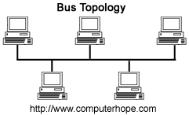

* **Star Topology:** All the nodes in the network are connected to a central device like a hub or switch via cables. Failure of individual nodes or cables does not necessarily create downtime in the network but the failure of a central device can. This topology is the most preferred and popular model.

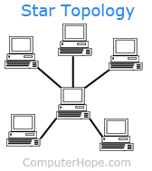

* **Ring Topology:**All network devices are connected sequentially to a backbone as in bus topology except that the backbone ends at the starting node, forming a ring. Ring topology shares many of bus topology's disadvantages so its use is limited to networks that demand high throughput.

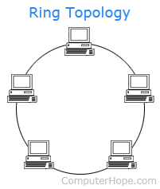

* **Tree Topology:** A root node is connected to two or more sub-level nodes, which themselves are connected hierarchically to sub-level nodes. Physically, the tree topology is similar to bus and star topologies; the network backbone may have a bus topology, while the low-level nodes connect using star topology.

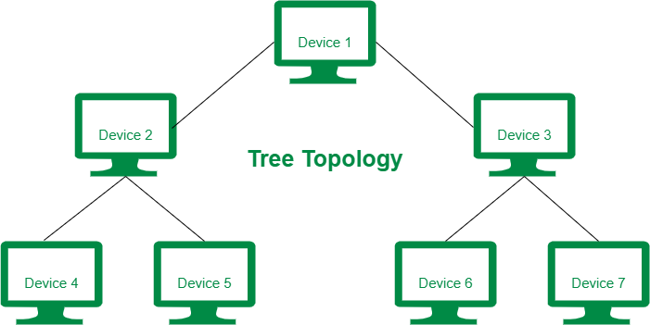

* **Mesh Topology:**The topology in each node is directly connected to some or all the other nodes present in the network. This redundancy makes the network highly fault-tolerant but the escalated costs may limit this topology to highly critical networks.

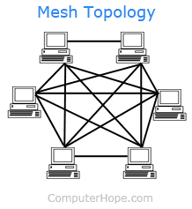

Q8. Protocols and their usage e.g. TCP/IP, http, https, ftp.

Ans. There are various types of protocols that support a major and compassionate role in communicating with different devices across the network. These are:

1. Transmission Control Protocol (TCP): TCP is a popular communication protocol which is used for communicating over a network. It divides any message into series of packets that are sent from source to destination and there it gets reassembled at the destination.
2. Internet Protocol (IP): IP is designed explicitly as addressing protocol. It is mostly used with TCP. The IP addresses in packets help in routing them through different nodes in a network until it reaches the destination system. TCP/IP is the most popular protocol connecting the networks.
3. Hyper Text Transfer Protocol (HTTP): HTTP is designed for transferring a hypertext among two or more systems. HTML tags are used for creating links. These links may be in any form like text or images. HTTP is designed on Client-server principles which allow a client system for establishing a connection with the server machine for making a request. The server acknowledges the request initiated by the client and responds accordingly.
4. Hyper Text Transfer Protocol Secure (HTTPS): It is a standard protocol to secure the communication among two computers one using the browser and other fetching data from web server. HTTP is used for transferring data between the client browser (request) and the web server (response) in the hypertext format, same in case of HTTPS except that the transferring of data is done in an encrypted format. So it can be said that https thwart hackers from interpretation or modification of data throughout the transfer of packets.
5. File Transfer Protocol (FTP): FTP allows users to transfer files from one machine to another. Types of files may include program files, multimedia files, text files, and documents, etc.